**Worksheet: Lernbüro**

**► Collect weather words by writing sentences:**

**Questions:**

**1. What can you do on a hot day?**

**2. What can you do on a cold day?**

***Example:***  ***On a hot day I can swim.***

***On a cold day I can drink tea.***

Stern: 6 Sätze, Mond 8 Sätze, Sonne 10 Sätze

**1)**

**2)**

**3)**

**4)**

**5)**

**6)**

**8)**

**9)**

**10)**

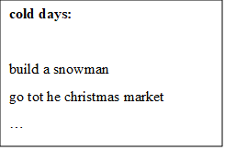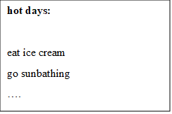

**HELP BOXES 😊**